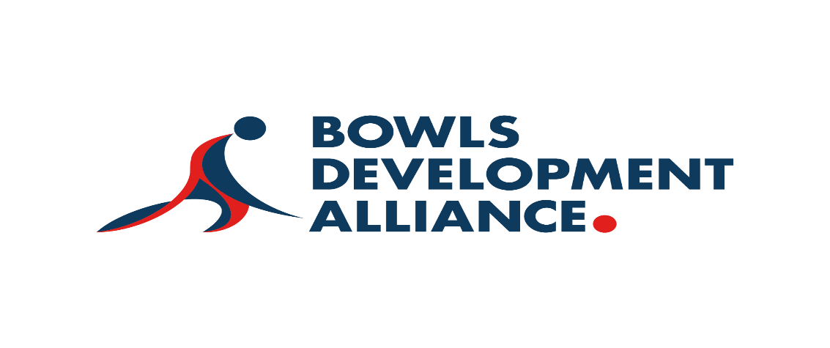
Application Form

Completing and returning the Application Form

Please complete the application form detailing how you meet the criteria and your motivation for joining us.

Applications should be sent by email to Steve Mitchinson, Governance and Finance Manager. SteveMitchinson@bowlsdevelopmentalliance.com

Candidates will initially be invited for an informal Zoom call with the Chair and Senior Independent Non-Executive Director, then to a final panel interview, at a date and time to be confirmed. Following references and approval by the Board, the successful candidate will join the Board from October 19th.
Personal details
To support the Bowls Development Alliance through this recruitment process, please use the personal pronouns you would like us to use through an interview process within this application form.

First Name(s)
Last Name |  | Preferred title
Address
Postcode
Email address
What is your preferred contact method? (phone, email, text, other)
What is the best number to contact you on?
What is the most convenient day and time to contact you?

How do you meet the requirements of the role as outlined in the Role Description?
Please outline your skills, knowledge and experience which are relevant to the role. You can format this as bullet points but please ensure that you directly reference the skills and knowledge as outlined in the Role Description.

How do you demonstrate the values of the Bowls Development Alliance?

Please provide examples of how you have demonstrated these values in your work or everyday life:

What would you hope to achieve within your role as an Independent Non-Executive Director at the Bowls Development Alliance?

Accessibility
The Bowls Development Alliance are committed to ensuring that all applicants can access the application and selection process for this role. Please provide details in the box below for any adjustments you will require to be made during the selection process (including interviews) should your application be progressed to the next stage.

Declaration
I give my consent to the storage of personal data contained within this form for the purposes only of this application process.

I can confirm and declare that the information provided on the form, to the best of my knowledge is complete, accurate and not misleading.

Signature
Date

